xCL_AT-170-E 7" eCommerce Terminal
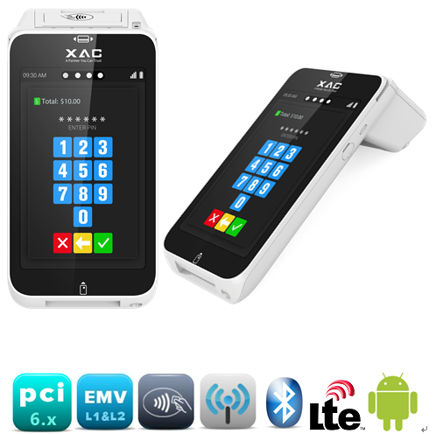
#retail #restaurant #hypermarket #grocerystore #foodcourt
SPECIFICATIONS
- PCI PTS 6.x , Android Secure 12 OS
- ARM Cortex-A53 quad-core 64bit
- 2 GB SDRAM +16 GB eMMC
- Can up to 4 GB SDRAM +64 GB eMMC
- 7”inch touch display, Secure Pin on glass
- 5MP Auto-Focus back camera (up to 8MP)

Security
- PCI PTS 6.x SRED
- Key Management: MK/SK, DUKPT
- TLS 1.2 support
- Secure Code Update Architecture

Certification
- PCI PTS 6.x with SRED
- GBIC, and CC compliant
- EMV Contact L1 & L2
- EMV Contactless L1
- PayPass, PayWave, DPAS, ExpressPay, Quickpass, JSpeedy
- Mastercard TQM
- Sony Felica

Thermal Printer
- 48 mm printing width with tear bar
- 34 mm diameter paper roll

Communication
- WI-FI 802.11 a/b/g/n/ac (2.4GHz & 5GHz)
- Bluetooth 5.0 Dual Mode
- 4G LTE (Support 2 SIM slots)

GPS
- - Tracking GPS (Optional)

Extension Ports
- USB Type C Connector x 1

Battery/ Power
- Typical capacity: 3.7V / 5300mAH
- Rated capacity: 3.7V / 5200mAH
Camera
- 5MP Auto-Focus back camera
- Optional 8MP camera
- Support 1D/2D barcode scanning (Optional)

Dimensions
- 231.1 (L) x 113.75 (W) x 71.76(H) mm
Hand held part thickness 27.5mm

Environmental
- Operating Temperature: 0°C to 50°C
- Storage Temperature: - 20°C to 60°C
- Operating Humidity: 5% to 85% (non-condensing)

Accessory
- DC switching power adapter (5V/2A)
- USB cable (type C to type A)
- Rechargeable battery
- Paper roll (34mm diameter)
- Quick user guide/safety instruction
- Privacy screen protector (Optional)
- Water resistant printer cover (Optional)
- Visual impaired accessory (Optional)
- Charging Base Device (Optional)
  - XC70-E (Ethernet + USB-A x 2+RS232 x 2)
  - XC70-C (Charge Only)
- Communication Box (Optional)
- USB2.0 type A x2
- USB2.0 type C x1 (device port)
- RJ-45 Ethernet (10/100) x1
- RJ-12 COM x1
- MicroSD card slot x1
- 12V Power DC Jack x1
- USB display dongle (Optional)
- Drive 2nd touch display to support
● ECR POS/KISOK/Vending Machine
Customer Facing Touch Display
CPU
- Qualcomm ARM Cortex-A53 quad-core 64bit (QCM2290) up to 2.0GHz
- Secure: MAXIM ARM Cortex-M3 SoC

Operating System
- Android 12

Memory
- 2 GB SDRAM +16 GB eMMC
Optional
- 3 GB SDRAM +32 GB eMMC
- 4 GB SDRAM +64 GB eMMC

Display
- 7” 1280x800 color TFT
- Capacitive touch screen display

AUDIO
- Audio Jack and Microphone

PINPAD
- Touch PINPAD

Magnetic Stripe Reader
- ISO 7811, 3-tracks

Smart Card Reader
- ISO7816-1/2/3 asynchronous T=0, T=1
- SLE4442 Memory Card
- Support 2 SAM slots

Contactless Reader
- ISO14443 type A/B
- ISO18092 (NFC)
- MiFare
- Felica

